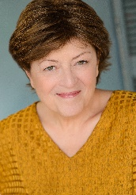 Blanca Bassion
7131 Altis Way, Apt 7113 Orlando, FL 32836 bbassion@gmail.com 954-383-5613
CAREER HISTORY
Substitute Teacher-March 2017-Present
DRAMA TEACHER—August 2000--February 2015
Broward County Public Schools
Responsible for teaching curriculum content and skills in theatre and performance to high school students using approved study materials.
Duties:
- Educating students in different acting styles, methods and techniques.
- Training students how to communicate, control, and project their voices.
- Creating lesson plans, teaching students theatre history.
- Assisting students in creating their own dramatic pieces.
- Organizing and managing the learning environment.
KEY SKILLS AND COMPETENCIES
Professional
- Florida Dept. of Education Certified English/Drama
- ESOL Certified
- SAG/AFTRA, AEA
Personal
- Open to receiving constructive criticism from staff and administration
- Always being respectful and considerate of the views of others.
- Being receptive to new ideas.
ACADEMIC QUALIFICATIONS
FIU -- Master’s Program, Live Music Operations 1998-1999
Barry University – Bachelor of Arts, Theatre 1975 – 1978

